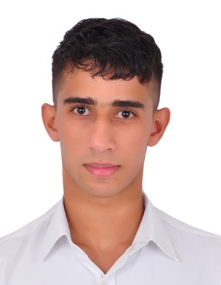**Curriculum vitae**

**Contact**

* **Phone number :** 36303508
* **Email** : [Hussainabdulshaheed.007@gmail.com](mailto:Hussainabdulshaheed.007@gmail.com)

**Objective**

Hardworking trainee seeking a position as an electrical technician, utilizing my diploma certificate, technical and interpersonal skills

**Personal information**

* **Name** : Hussain Abdulshaheed Ebrahim
* **Gender** : Male
* **Nationality** : Bahraini
* **Date of birth** : 01/06/1999
* **Marital status** : Single
* **Address** : Sanad , Bahrain

**Education**

* Sheikh Abdulla bin Isa Secondary Industrial Boys School Sept 2014 – June 2017

[Information Technology Specialization]

**Qualifications**

**: Languages**

* Native Arabic
* Good English

**Skills:**

* Teamwork
* Ability to work under pressure

**Interests**

* Sport
* Volunteer work

**References**

* References available upon request